MY DRIVING ACADEMY
410-298-1500
410-298-6771
Registration Form

This Form Must Be Completed in its Entirety
(Timings are subject to change)
Select Class: ( ) Morning ( ) Evening ( ) Online Morning ( ) Online: Evening
10AM-1:15PM 6PM-9:15PM 10AM-1:15PM 6:00PM- 9:15PM

Course Start Date: _____________

Student Name Student Name First Middle Last
FirstF

Street Address

City State Zip Code__________________

Home Phone Parent/Guardian Work Phone___________________

Cell Phone Email_______________________________

Under 18? _________

Date Of Birth(mm/dd/yyyy) Sex Learner’s Permit (Yes / No)

Learner Permit #__________________________________________

Permit issue Date_______________

Credit Card # *For card payments, a $5 service charge will be added to the total*
Exp Date
CVC
How did you hear about us?
( ) Verizon yellow pages ( ) Friend ( ) Siblings ( ) website ( ) Yellow book ( ) other: __

PAID: YES | NO | BALANCE DUE: ______

*All Classes subject to Cancellation Due to Low Enrollment

My Driving Academy (410)-298-1500
Please Go online and Log in to Twitter.com/Maryland
Find out all the news, updates and change in schedules
Student Expectations and Academy Policies
1. Student is expected to be punctual and attend all class sessions. If a student is late, a 15 minutes grace period may be granted. After the grace period is over, student will be marked absent and required to make up that session, if any unexpected event occurs, student/ parents must contact Academy office immediately.
2. Student is expected to be courteous and respectful to instructors, office personnel and all Students. Inappropriate behavior may result in dismissal from class. No credit will be allowed for the day of incident and dismissal could be permanent without any refund.
3. All cellular phones, beepers and CD/cassette players are to be completely turned off during classroom & BTW sessions.
4. Student is expected to come prepared with writing material to take important notes.
5. No eating, drinking, and smoking in the classroom. Appropriate break -time is scheduled during each classroom session to allow students time for these activities.
6. Profanity, vulgarity, sexual harassment of male /female students bullying, argumentative, resentment of authority, immaturity, and violent behaviors are not acceptable in the entire session and will not be tolerated for any reason. In order to maintain a positive learning environment, we reserve the right to remove a student from one or more classroom session(s). Parent/guardian will be notified if student is less than 18 years age.
7. Academy management assumes no responsibility for any incident occurring outside the Academy before, during and after class sessions.
8. MVA regulations require for the student to attend the first day of the class, if the student miss the first day, he/she will be re-scheduled to the next course automatically according to the Academy course schedules.
9. Regular attendance is recommended. If a student misses any classroom session, will be considered “No Show”. A student has to reschedule the class. To reschedule any missing session the student has to ask the instructor for any availability of sufficient room in the class. Make up fee is $ 50.00 per class. INT.________
10. Student is not allowed to miss more than 4(four) classroom sessions (12.00 hours) consecutively, Student will be required to retake entire classroom session if missing more than 12.00 hours and repay the whole amount.
11. A minimum $150 payment is required at the time of registration. Receipt must be brought on the first day of course begin. All balances must be paid in full by the end of the first week of the classroom session or a $40.00 late fee will be charged. If a student fails to pay by the second week, he/she will not be permitted to sit in class. A makeup fee will be applied in addition to late fee. In case of withdrawal from Academy after classroom instruction hours, 15% of the total amount paid divided by 30 hours for each hour of classroom not completed will be charged, or withdrawal during BTW 85% of the total amount paid divided by 6 hours for each hour of instruction not completed will be charged. All returned checks $40 will be charged and the refund check will be given to the customer (No cash). INT.________
12. All efforts are made to complete BTW sessions as quickly as possible (up to18 weeks). BTW drive time appointments may be scheduled by My Driving Academy office during second week of class session or you can get BTW schedule by calling Academy office after 30 hours class session is over. Academy will not remind you for the given BTW sessions. However, you can contact Academy office, during office hours, if you have any doubt regarding your BTW schedule. Students/parents must understand that the BTW sessions are an evaluation period for the student, therefore student is recommended to have minimum of 25 hours of driving practice before coming to us. It is a pass and fails session. In these 6 hours instructors evaluate the students on their performance. The instructor will also inform the student about his/her weak points and give them further instruction on how the student can fix those mistakes. If a student fails to show proper control of the vehicle, he/she may not pass the course and the instructor may recommend rescheduling the remaining BTW sessions to get more practice with his/her mentors. A Student must meet the following criteria before calling the Academy office for BTW. The Academy will NOT call the student for BTW if they do not have their permit during the class session. Instead, the student must call the academy once they get their permit.
a. Have paid full amount of the course including “No show” late fee etc.
b. Student MUST bring his/her Maryland state permit and skill log book with a recommended minimum of 25 hours logged and signed by a parent/guardian or mentor.
13. For safety purpose, students must wear appropriate clothing for entire driver Ed sessions. (No open-toed, flip flops or platform shoes during behind the wheel sessions). If you require glasses or hearing aid during your drive session you MUST bring those,
14. Students must come or brought to the classroom location for behind the wheel lessons. If a student is late for more than 20 minutes from BTW scheduled time, will be considered “No Show”.
15. If a student must miss a driving session, at least 24 hours notice is required, during the office hours (10 am to 6 pm Monday through Friday, otherwise in both cases a $60.00 will be charged (as a no show fee)to defray the cost of the instruction. No exception at all. Be noted, no shows will result in your completion date being delayed (Could pass 18 weeks). INT.________
16. Student may reschedule twice (24 hours in advance). After two rescheduled driving appointments, there will be $40 service charges. The Driving Academy can change or reschedule the BTW hrs due to any case of emergency.
17. Students who do not complete the entire driver’s education course (all required classroom and driving sessions) within 48 weeks (1 year)of their original classroom session date will be charged a $100 reinstate fee. The record of the student stays in our system for 3 years finished or unfinished. After 3 years, student’s record will be deleted out of the system.
18. Upon completion of 30 hours of classroom and 6 hours BTW sessions successfully, the Academy will mail the students’ certificate electronically to the MVA. The certificate may take approximately 48-72 hours to be in their system. For your driving test appointment, visit www.marylandmva.gov. *Course will be taught in English*

I HAVE READ AND AM AWARE OF THE EXPECTATIONS AND ACADEMY POLICIES

Students Signature Date _________ Parents/guardians signature ________________ Date _________
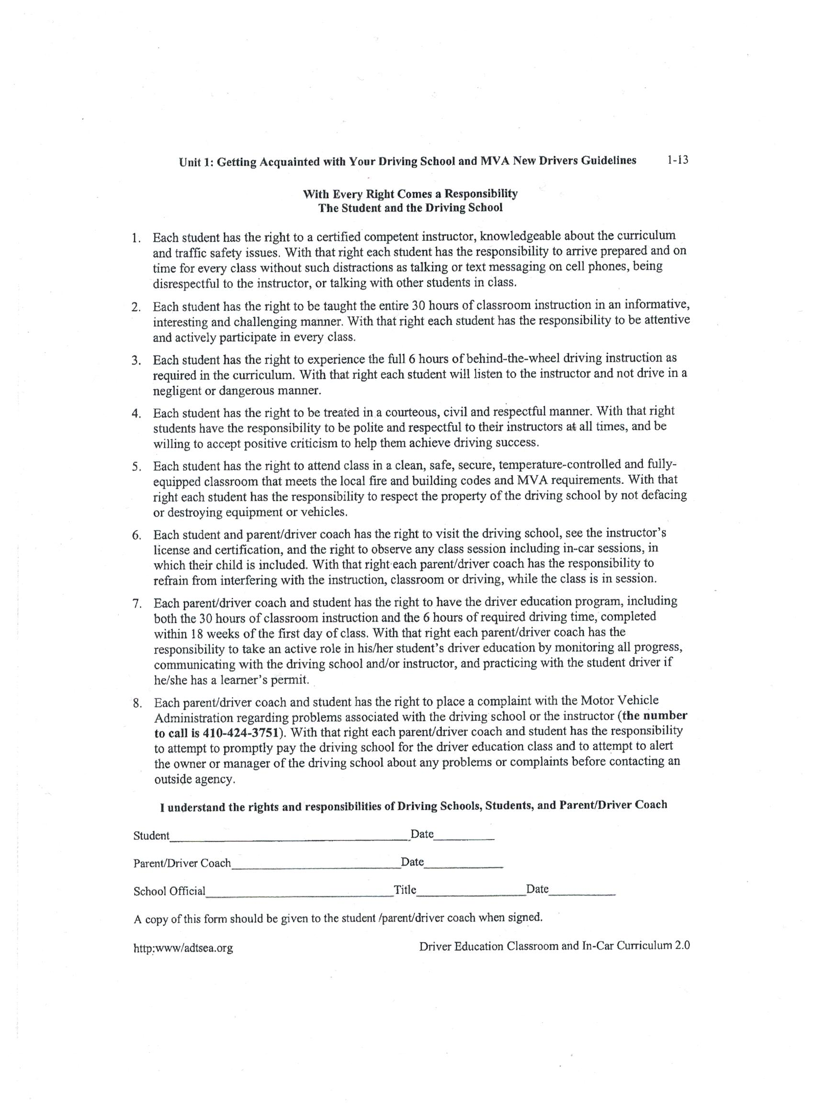
(If the student is under 18)

